“India… Agricultural Program
February 2022
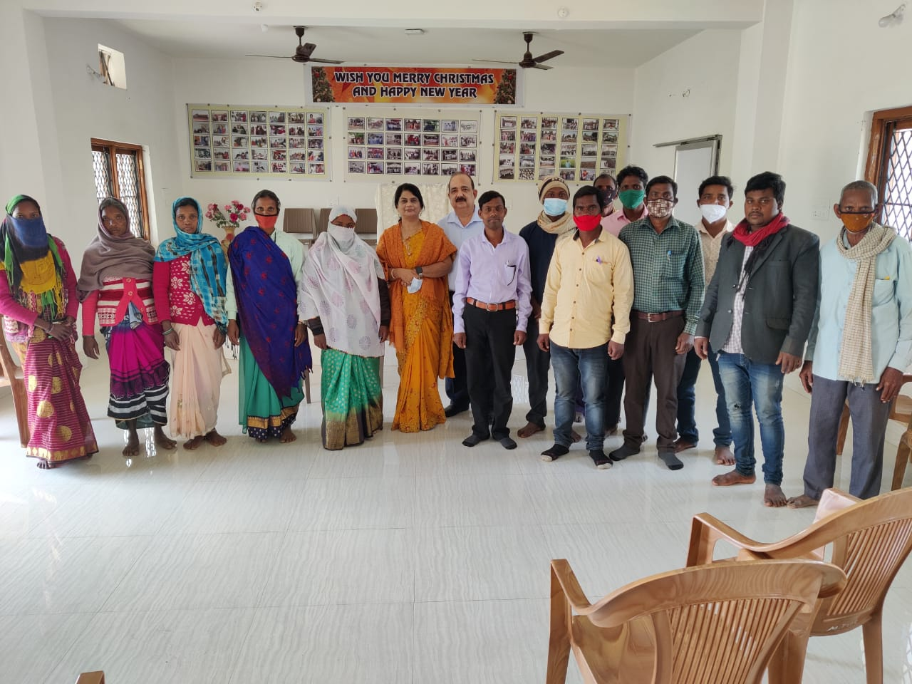
David and Sunisha Henry selected 15 individuals from the 8 rural churches to participate in the agricultural program. These individuals were living below the poverty line. Just as important, these individuals had taken responsibilities within the village churches. They were brought to the training center to be introduced to the program.
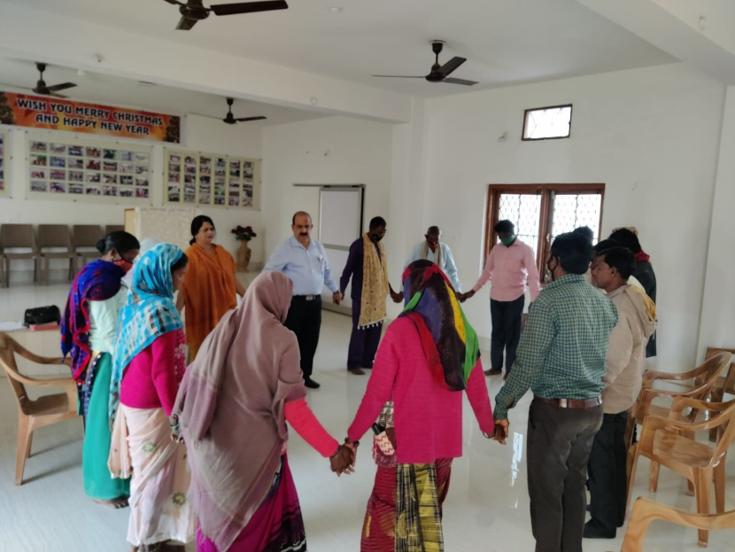
Sunisha used the parable of “Talents” from Matthew 25:14-30 as an introduction to the program. Special emphasis was placed on those who show more responsibility will be given more. This is the basis of the 4-step program that the Henry’s have created.
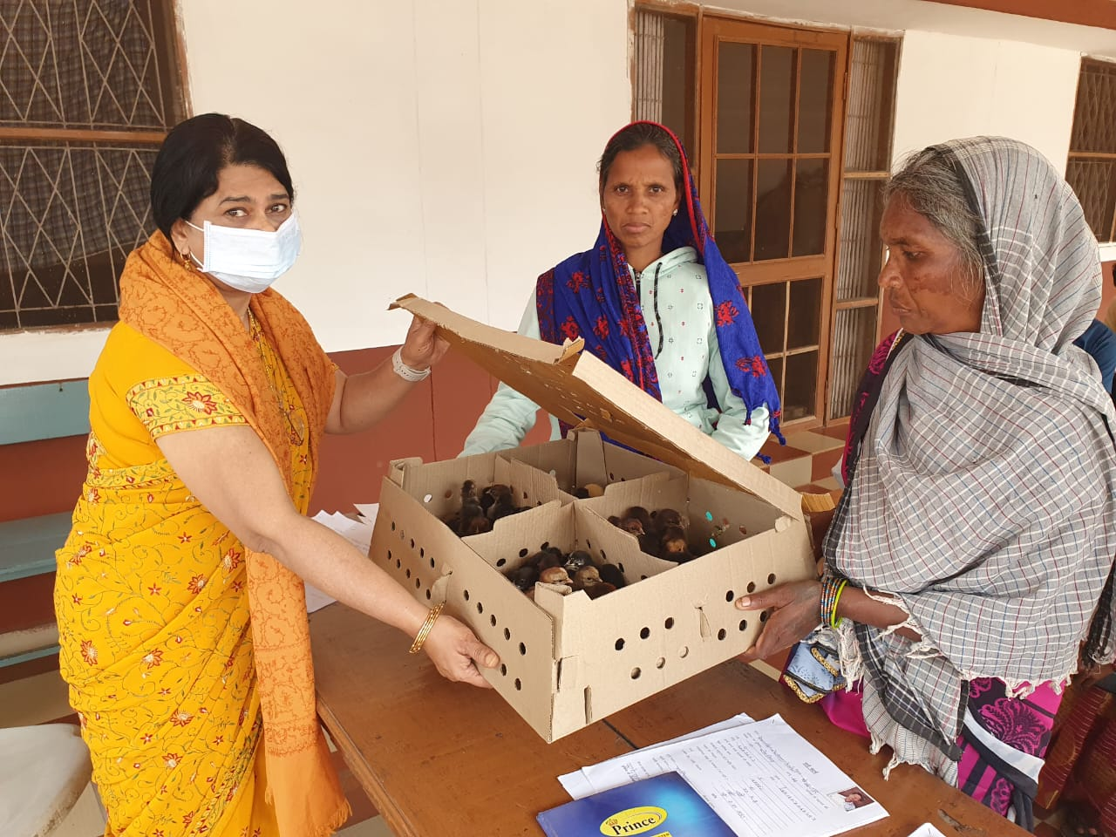

Each participant was given 30 chicks. David’s research and previous set-ups have shown with proper care and effort, in 6 months these 30 chicks will yield eggs and meat worth 4,000 rupees per month. 4,000 rupees monthly is about half of the minimum living wage for India. 4,000 INR is equivalent to about $54 USD.

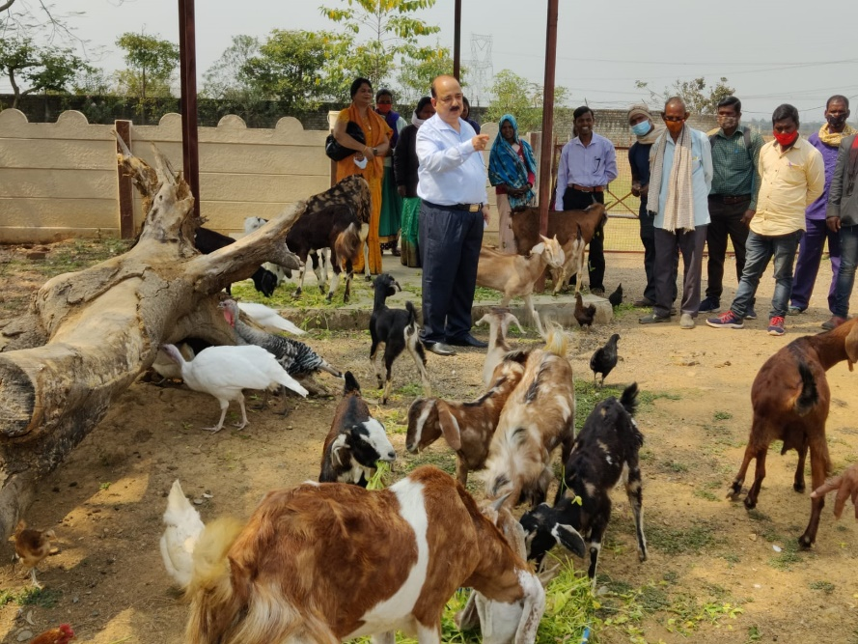
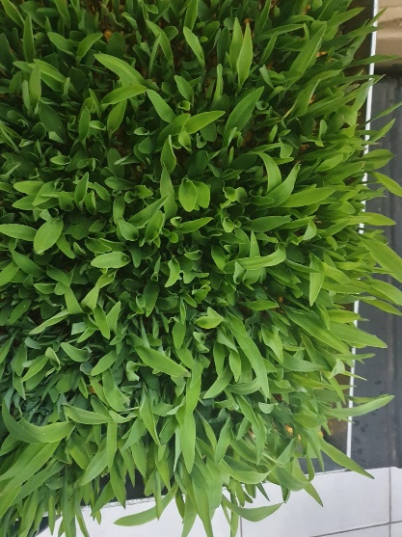
Step 2 of the program would involve plant farming. This would include training in traditional farming techniques as well as an introduction, training, and equipment needed for hydroponic farming of certain vegetables. Participants would only qualify if they have shown results and responsibility with chicken farming.
Step 3 of the program has two options, goat farming or fish farming. Remember the parable of “talents”! To qualify for Step 3, the participants must show responsibility and results from both the chicken farming and plant farming. Once qualified, they will be provided training and equipment needed to succeed.
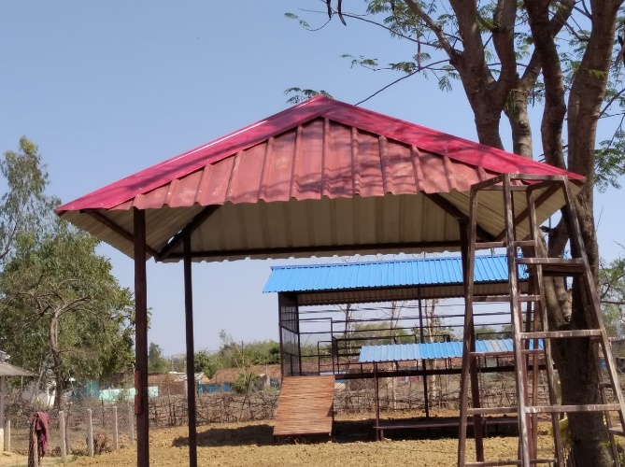
This is a significant step. Not only is the training much more intense, but in the case of goat farming, there is a significant outlay for the ministry in providing shelter and fencing. The shelter system was designed by David with shelter for chickens at ground level and goats housed above. Manure would benefit the farming aspect already in place.

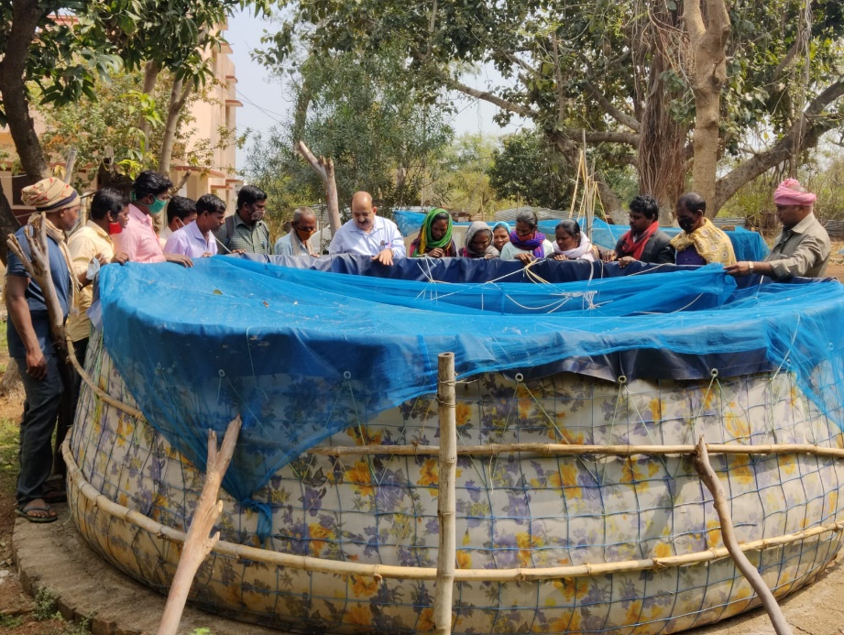
Like goat farming, the ministry will provide equipment and training for fish farming. A smaller footprint has been designed for use in the rural villages. Water can be scarce during the hot summers. Also, in previous set-ups using ponds, theft was a significant problem.

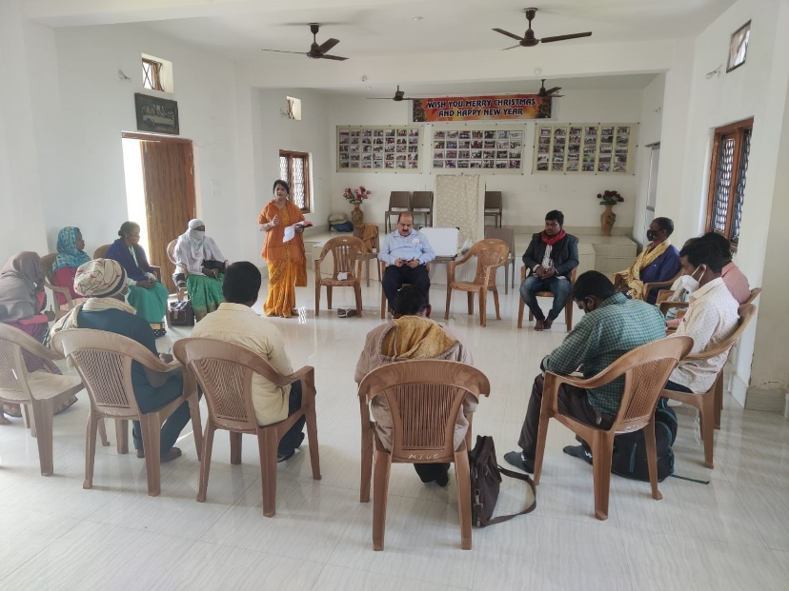
At this point in the program, there has been a large “investment” in a successful participant. Besides equipment, teachers from the technical schools have been working onsite with the participants providing help and follow-up training. Pastors have been monitoring their involvement both within the church and the village. Remember David’s goal is to make all those involved in his ministry disciples of Jesus Christ and to make them self-sufficient. Truly a Holistic approach to ministry.

Now for Step 4. With success in all three previous steps, a participant has developed a small business. Small business management skills training is in fact Step 4. Please consider how life changing this program is for those living in poverty. Furthermore, what a testimony to others as they watch the transformation of these disciples of Jesus Christ.

